1. Summarize chapters from 11.1 to 11.3 in the text book.

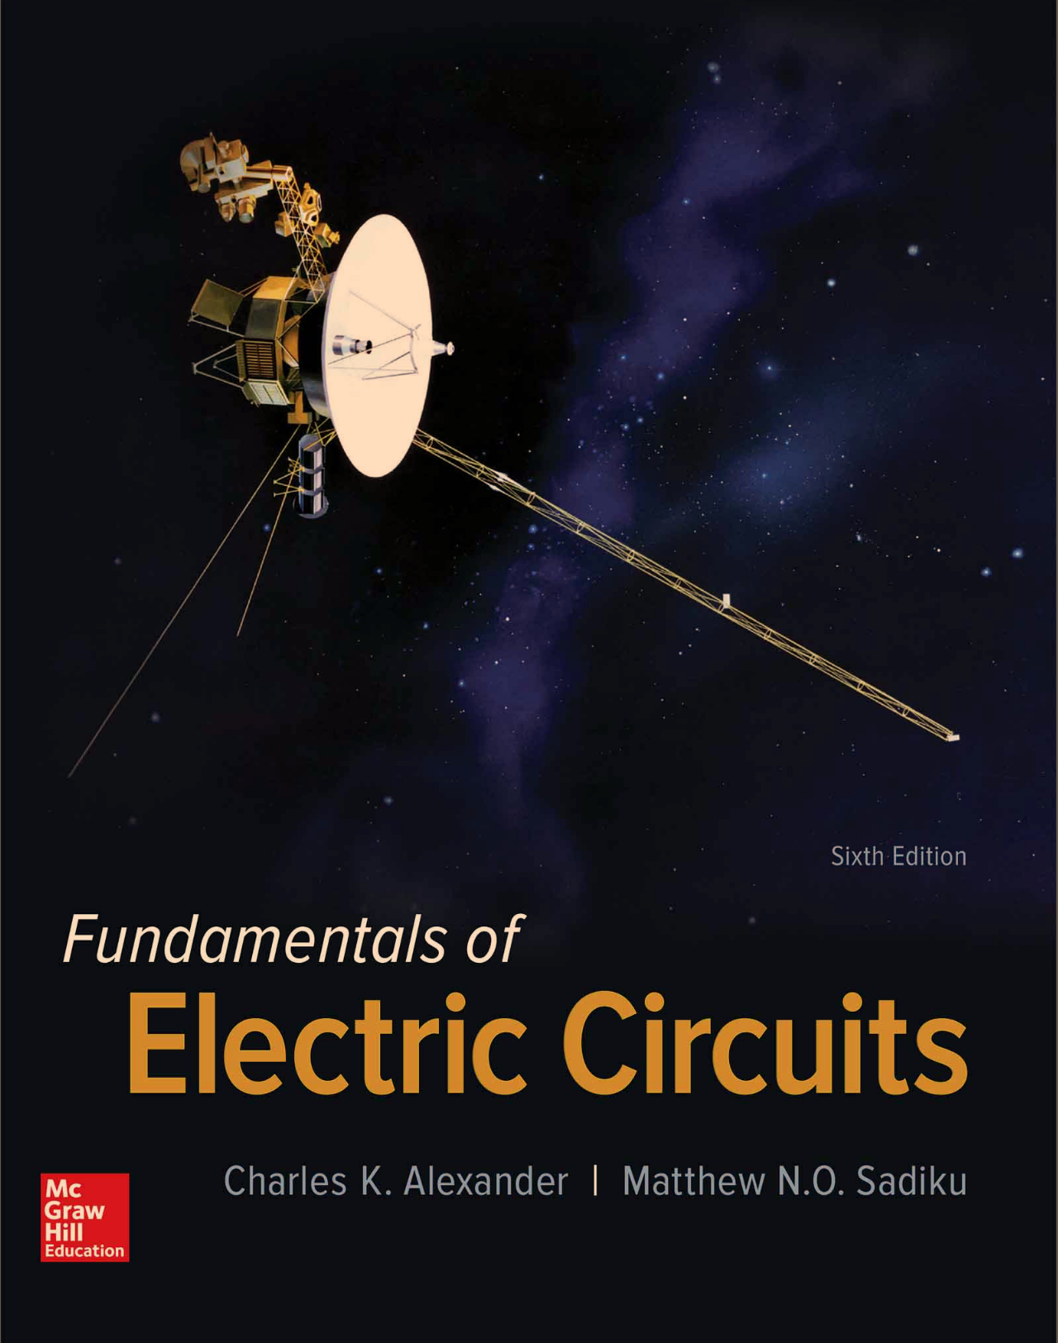

1. Please solve and write the answer to all of the given examples in handwriting. And take a picture for the solutions and attach the picture to the assignment file.